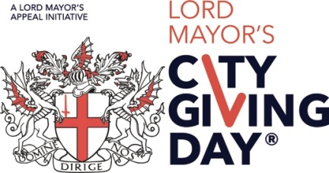

Supporting City Giving Day
Sharing your stories

This year we would like to feature your stories on our website and our social media channels. If you would like to be included, please provide copy as detailed below. Please also provide a good, print quality, high resolution photo (1 MB+) which conveys the success and spirit of City Giving Day as well as a company logo to accompany the piece.

YOUR DETAILS

Contact name |  | Company name
Email address |  | Telephone no
Twitter |  | Facebook

WE ARE SUPPORTING …

Please provide a brief overview of which charity/charities/causes you will be supporting, and a quote (50 words) about why you are supporting City Giving Day 2022, e.g.:

- The Duke of Edinburgh’s Award
- Shelter
- “City Giving Day is a fantastic opportunity to showcase how we are supporting our charity partners …”

YOU WILL FIND US …

Tell us what you’ve got planned (50 words), e.g.:

- Racing bikes around the city and creating a lovely bake sale to celebrate the day

YOU SHOULD JOIN US …

Tell us why other businesses should get involved in City Giving Day (50 words), e.g.:

- “All businesses should be involved with City Giving Day as it gives us a chance to celebrate the brilliant charity work we do, etc.”

CHARITY IN ACTION

A quote from your charity partner (25 words) – include full name, job title (if appropriate)

Once completed, please email to cgd@thelordmayorsappeal.org

