


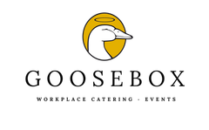

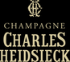

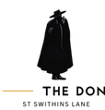
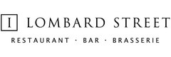
THE LONG LONG LUNCH TO SUPPORT THE LADY MAYOR’S CITY GIVING DAY
Wednesday 23 September 2026

MENU
Salmon Confit
with beetroot tapenade

Bleeding Heart
Wood Pigeon salad
with pickled blackberries and bitter autumn leaves

Goosebox Hospitality by No1 Lombard Street
Cod with mussels and cider velouté,
braised leeks and mash potatoes

The Don Restaurant
Pomme Verte
with Granny Smith apple parfait

Coq D’argent
Les Coeurs de Macaron and Coffee

Bleeding Heart

Champagne, canapés, Amuse Bouche and three-course lunch with matching wines for £140.00 per person.

Bookings: benoit@ thedonlondon.com

For enquiries, please contact: Benoit@thedonlondon.com / Georges@bleedingheart.co.uk

